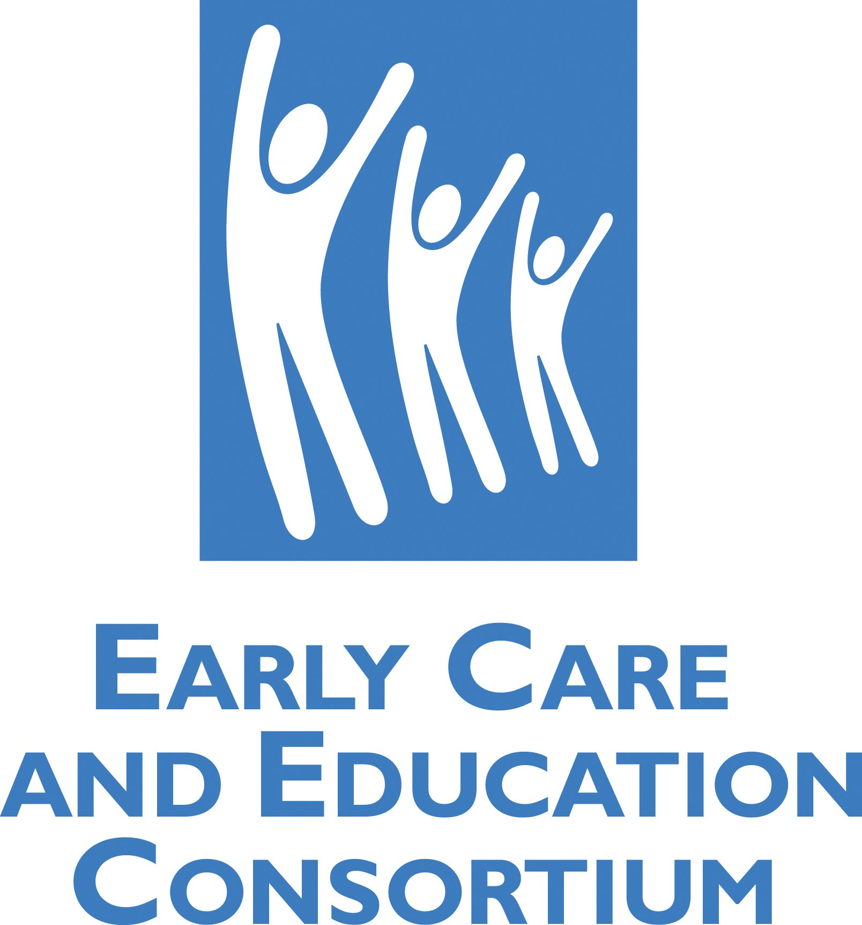 | Early Care and Education Consortium  1313 L Street NW, Suite 120, Washington, DC 20005  Phone (202) 408-9626 www.ececonsortium.org

January 31, 2015
Child Care Information Exchange
17725 NE 65th Street, B-275
Redmond, WA 98052

To whom it may concern:

It is with great pleasure that I nominate Rachel Demma as a 2015 Child Care Information Exchange Emerging Leader. Rachel is skillfully and successfully using her advocacy skills as the Policy Director for the Early Care and Education Consortium (ECEC) to bring about positive change for young children, families and providers. The Consortium is an alliance of multi- state / multi -site community child care providers, state child care associations and educational services organizations who are committed to bringing quality to scale in the thousands of socio-economically diverse ECEC Member Centers located throughout the 50 states and the District of Columbia.

Her national leadership is illustrated by her direct outreach to and positive response from congressional legislators during the bi-partisan reauthorization of the Child Care and Development Block Grant (CCDBG), the development of the Strong Start Bill and is continuing with the pending reauthorization of the Elementary and Secondary Education Act (ESEA). Rachel’s impact continues through ECEC issue briefs, formal comments on pending initiatives, and in person input /dialogue on early childhood issues with White House Domestic Policy Staff, Department of Health and Human Services and Department of Education Administration officials, and National Advocacy Groups including the National Association of Regulatory Administrators.

Through these collaborative efforts, including her work with state legislators and local advocates, she is helping ensure a positive transition occurs as new legislation is translated into implementing guidance for childhood field operations. Her efforts are improving day to day program quality for children, increasing timely accessibility to full day /full year care and helping maintain affordability for low and middle income families and the providers of these services.

Rachel brings a ‘real world’ early childhood perspective to lawmakers and policy administrators. As a frequent presenter at national conferences and a contributor to various early childhood webinars and publications, she is an effective and respected voice for both families and child care providers. Her strong leadership is helping high quality community child care programs enhance the productivity of parents in today’s workforce, while preparing the children in their care for success in school and their future role in tomorrow’s workforce. Rachel may not be as well-known as some other nominees, but the positive impact she is making as an emerging national leader will stand the test of time.

Sincerely,
M.-A. Lucas
Executive Director
Early Care and Education Consortium

