Organization/Site

Date

Site Representative

Signature

Agreement for Logo Usage

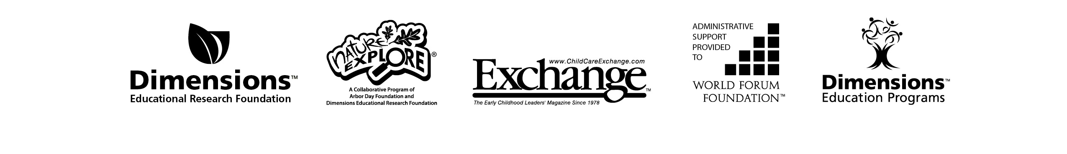

Dimensions Educational Research Foundation (Dimensions) has granted you access to a logo for your organization’s use. Dimensions includes the Nature Explore Program (a collaborative program of Arbor Day Foundation and Dimensions Educational Research Foundation) as well as Dimensions Education Programs and Exchange Magazine. In addition, Dimensions also provides administrative support for the World Forum Foundation.

The following terms and conditions govern your use of the logo provided by Dimensions and constitute a binding agreement between you and Dimensions. “You,” for the purposes of this agreement, is either the individual receiving the logo, or—if you are entering into this agreement on behalf of your employer—then such employer or agency. By obtaining or using the logo from Dimensions, you agree to be bound by and comply with the terms of this agreement.

*Permitted Use:*   
Subject to the terms of this agreement you may use the logo, solely for a one-time approved use (as specified below). Logo must be reproduced in its entirety.

*Restrictions:*

* You may not sell the logo or otherwise distribute for a fee. Your right to use the logo is non-transferable and may not be traded, sublicensed, sold, or otherwise transferred.
* This is a single-use permission agreement; any future use will require separate permission.
* No modification or retouching is permitted.
* You may not use logo for promotion or advertising of any product or service other than the agreed upon   
  usage specified below.

*Termination:*    
Dimensions reserves the right to immediately terminate your use of the logo at its discretion, including in the event that Dimensions determines that your conduct is unacceptable or in the event that you breach this agreement.

I agree to the terms above for permission to use:    
INSERT USAGE HERE

***Please sign and return this agreement via email or fax to (402) 467-6118***